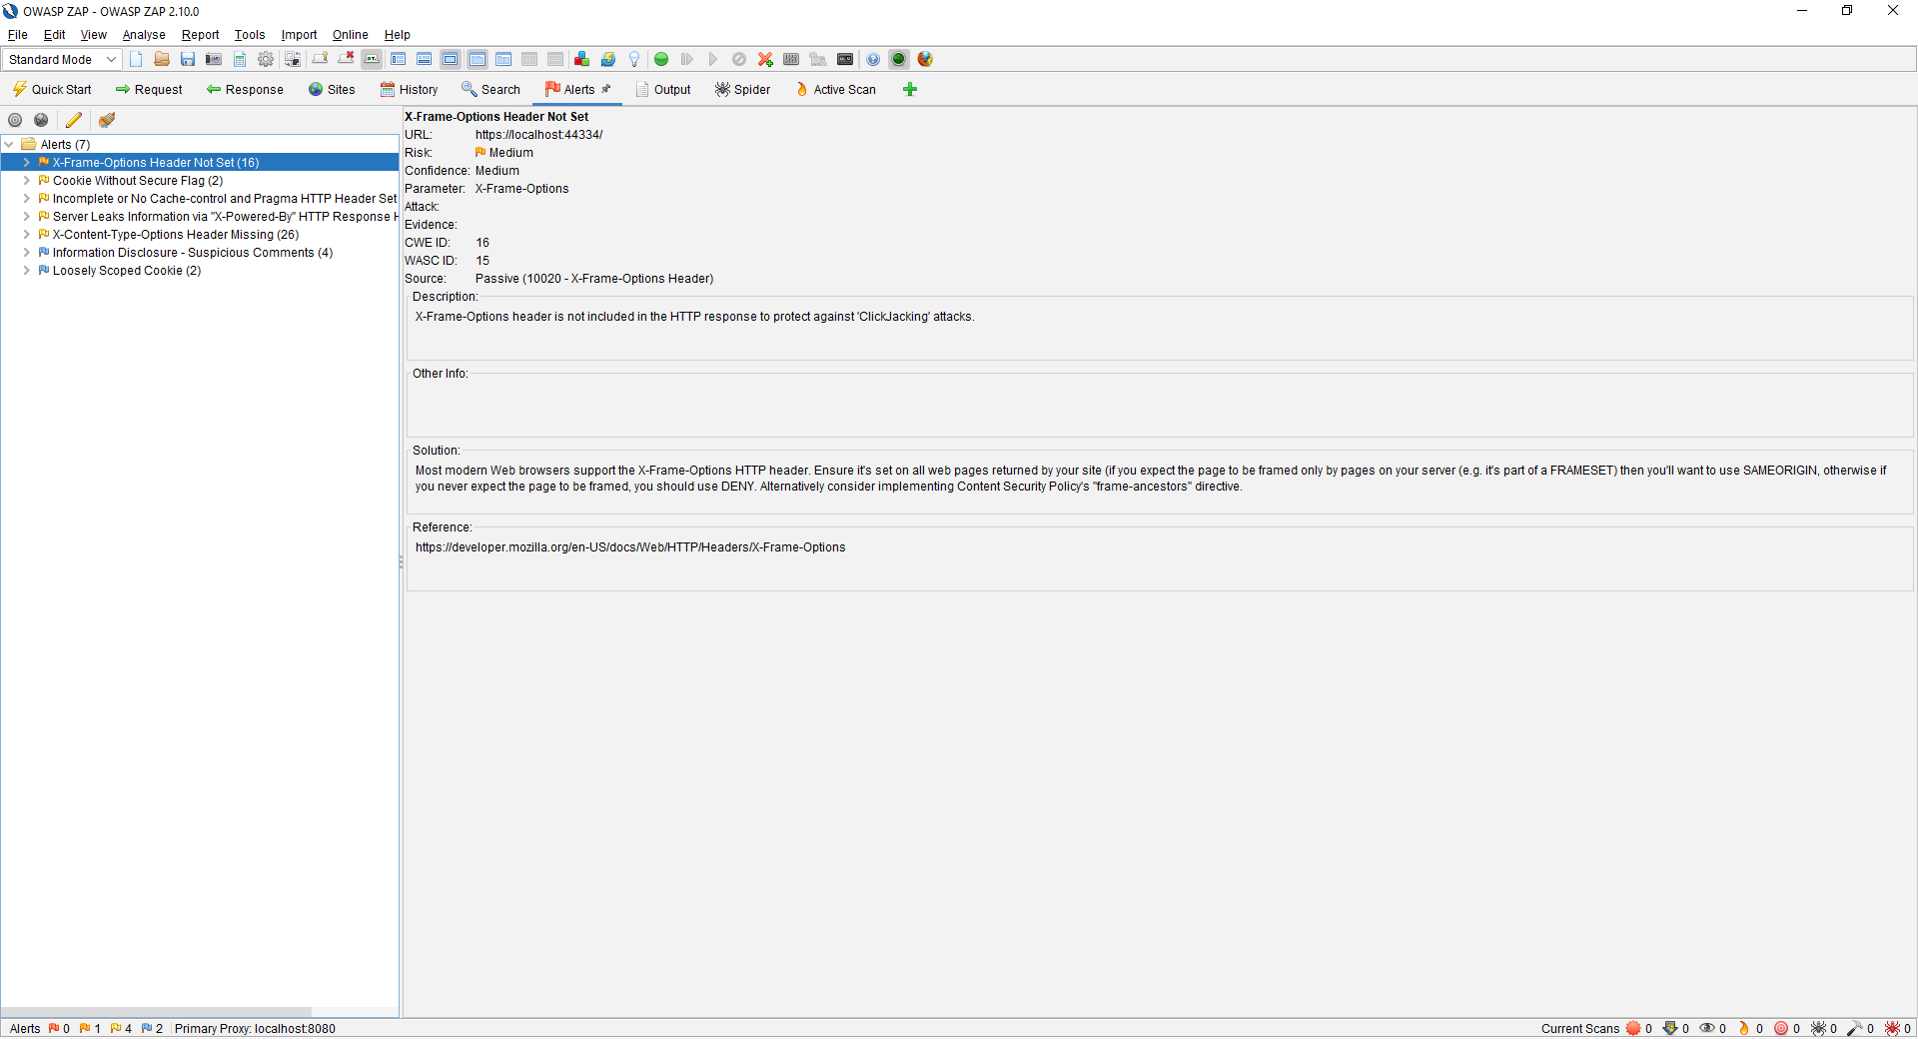

As seen below the Zap added itself to admin role. I think it used the password and intelligently used it to create an admin from the cpp message page

